A bio-functional polymer that prevents retinal scarring through modulation of NRF2 signalling pathway

Here we explore the use of DeSeq2 to extract differential expressed genes in epithelial cells treated under four conditions: Media only control, Polymer alone, TNF-α and TGF-β1 (TNT) alone, TNT + Polymer. The purpose of this pipeline is to replicate the results published by [Parikh et al., 2022](https://pubmed.ncbi.nlm.nih.gov/35589753/) which showed that upregulation of genes that are important for the NRF2 signalling pathway is associated with the presence of the polymer and not necessarily TNT.

library(GEOquery)

library(DESeq2)

library(dplyr)

library(tidyverse)

library(vsn)  
library(data.table)

# Set the working directory  
setwd("/Users/seymour/Desktop/Bioinformatics/Advanced_Computational_Biology_BIOL0050/Week3/Gene_Exp_analysis_3/")

gse <- getGEO(filename = "GSE176513_series_matrix.txt.gz", GSEMatrix = TRUE, getGPL = FALSE)

# Create a data frame with samples and conditions  
sample_info <- pData(gse)  
condition_df <- data.frame(Sample_ID = sample_info$description, Condition_name = sample_info$title) %>%  
 mutate(Sample_ID = gsub("gene_count_matrix.csv --", "", Sample_ID)) %>%  
 mutate(Condition = substr(Sample_ID, 1, 1)) %>%  
 mutate(Duration = substr(Sample_ID, 4, nchar(Sample_ID))) %>%  
 mutate(cond_duration = paste(Condition, Duration, sep = "_")) %>%  
 mutate(Condition_name = substr(Condition_name, 1, nchar(Condition_name) - 4)) %>%  
 mutate(Condition_name_short = gsub(" \\(8h\\)| \\(24h\\)", "", Condition_name))

#Separate the 8h and 24h samples  
condition_df_8h <- condition_df[condition_df$Duration == "8h", ]  
condition_df_24h <- condition_df[condition_df$Duration == "24h", ]

#Read in the count data  
count_data <- read.csv(gzfile("GSE176513_gene_count_matrix.csv.gz"))

col_order<- condition_df$Sample_ID  
rownames(count_data) <- count_data$EnsemblID  
aligned_count_data <- count_data[, col_order]

all_dds <- DESeqDataSetFromMatrix(countData = aligned_count_data, colData = condition_df, design = ~ Condition)

## Warning in DESeqDataSet(se, design = design, ignoreRank): some variables in  
## design formula are characters, converting to factors

all_dds <- all_dds[ rowSums(counts(all_dds)) > 1, ]  
all_dds <- estimateSizeFactors(all_dds)

vsd <- vst(all_dds, blind = FALSE)  
sampleDists_vsd <- dist(t(assay(vsd)))  
sampleDistMatrix_vsd <- as.matrix( sampleDists_vsd )  
rownames(sampleDistMatrix_vsd) <- paste(vsd$Condition_name)  
colnames(sampleDistMatrix_vsd) <- paste(vsd$Condition_name)

### Distance matix of gene expression profiles from RNA sequencing of all four groups (Media only, 1 wt% poly(CEP), TNT and 1 wt% poly(CEP) + TNT at two time points (8 and 24 h), each done in triplicates. 24 h), each done in triplicates. The intensity of each box corresponds to the distance value shown in the legend.

colors <- colorRampPalette(rev(brewer.pal(9, "Blues")))(255)  
heatmap <- pheatmap(sampleDistMatrix_vsd,  
 clustering_distance_rows = sampleDists_vsd,  
 clustering_distance_cols = sampleDists_vsd,  
 col = colors,cellwidth=8,  
 cellheight=8,treeheight_row = 8, treeheight_col = 8, fontsize_row = 7,fontsize_col = 7)

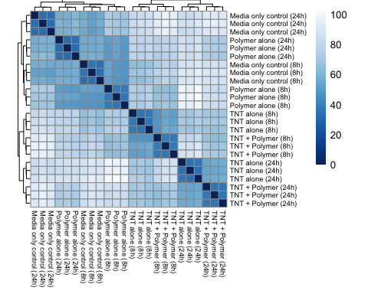

pca_data_condition<-plotPCA(vsd, intgroup="Condition_name_short")  
pca_data_condition

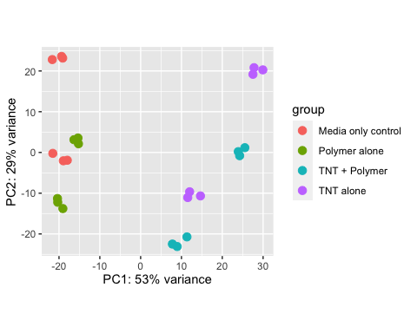

pca_data_duration<-plotPCA(vsd, intgroup="Duration")  
pca_data_duration

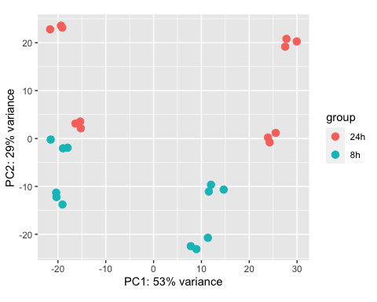

library(ggfortify)  
library(patchwork)  
  
pca_data_duration <- plotPCA(vsd, intgroup = "Duration")  
pca_data_condition <- plotPCA(vsd, intgroup = "Condition_name_short")  
match(pca_data_duration$data$name,pca_data_condition$data$name)

## [1] 1 2 3 4 5 6 7 8 9 10 11 12 13 14 15 16 17 18 19 20 21 22 23 24

pca_data_condition$data$Duration<-pca_data_duration$data$Duration  
pcaData<-pca_data_condition$data  
ggplot(pcaData, aes(x= PC1, y = PC2))+geom_point(size= 3, aes(shape=Duration, fill=Condition_name_short))+scale_shape_manual(values=c(21, 25))+ scale_fill_manual(values = c("#E69F00", "#56B4E9","Red","Green"),guide = guide_legend(override.aes = list(shape = 22)))+scale_color_discrete()+labs(x = paste0("PC", pca_data_condition$x[, 1]), y = paste0("PC", pca_data_condition$x[, 2])) +ggtitle("PCA Plot - Condition") +theme_minimal()

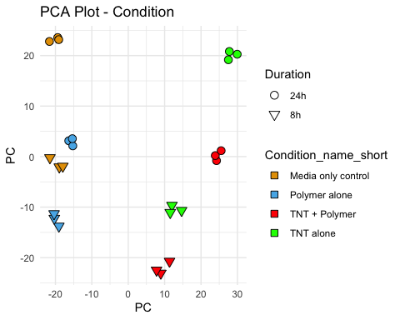

plot_duration <- autoplot(pca_data_duration, data = vsd$Duration, shape = "Duration") +  
 labs(x = paste0("PC", pca_data_duration$x[, 1]), y = paste0("PC", pca_data_duration$x[, 2])) +  
 ggtitle("PCA Plot - Duration") +  
 theme_minimal()  
  
# PCA plot with intgroup="Condition_name_short"  
pca_data_condition <- plotPCA(vsd, intgroup = "Condition_name_short")  
plot_condition <- autoplot(pca_data_condition, data = vsd$Condition_name_short, colour = "Condition_name_short", shape="Duration") +  
 labs(x = paste0("PC", pca_data_condition$x[, 1]), y = paste0("PC", pca_data_condition$x[, 2])) +  
 ggtitle("PCA Plot - Condition") +  
 theme_minimal()  
  
# Combine the two plots  
combined_plot <- plot_duration + plot_condition  
  
# Display the combined plot  
print(combined_plot)

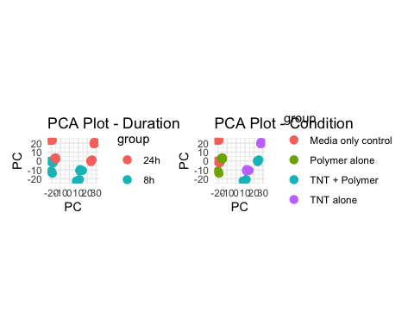

#Create a function to investigate number of significant genes that are differentially expressed between conditions  
create_dds <- function(condition_xh) {  
 col_order <- condition_xh$Sample_ID  
 aligned_count_data <- count_data[, col_order]  
 dds <- DESeqDataSetFromMatrix(countData = aligned_count_data, colData = condition_xh, design = ~ Condition)  
 dds <- dds[ rowSums(counts(dds)) > 1, ]  
 dds <- estimateSizeFactors(dds)  
   
 dds <- DESeq(dds)  
   
 res<-results(dds, contrast=c("Condition","A","B"))  
 sigs<-na.omit(res)  
 sigs<-sigs[sigs$padj<0.05,]  
 cat("Number of genes sig in poly(CEP) alone compared to media only:", nrow(sigs), "\n")  
 #print(nrow(sigs))  
   
 res1<-results(dds, contrast=c("Condition","C","D"))  
 sigs1<-na.omit(res1)  
 sigs1<-sigs1[sigs1$padj<0.05,]  
 cat("Number of genes sig in poly(CEP)+TNT compared to TNT:", nrow(sigs1), "\n")  
   
 return(dds)  
}

dds_8h <- create_dds(condition_df_8h)

## Warning in DESeqDataSet(se, design = design, ignoreRank): some variables in  
## design formula are characters, converting to factors

## using pre-existing size factors

## estimating dispersions

## gene-wise dispersion estimates

## mean-dispersion relationship

## final dispersion estimates

## fitting model and testing

## Number of genes sig in poly(CEP) alone compared to media only: 3472   
## Number of genes sig in poly(CEP)+TNT compared to TNT: 3790

dds_24h <- create_dds(condition_df_24h)

## Warning in DESeqDataSet(se, design = design, ignoreRank): some variables in  
## design formula are characters, converting to factors

## using pre-existing size factors

## estimating dispersions

## gene-wise dispersion estimates

## mean-dispersion relationship

## final dispersion estimates

## fitting model and testing

## Number of genes sig in poly(CEP) alone compared to media only: 6646   
## Number of genes sig in poly(CEP)+TNT compared to TNT: 5162

res_8h1<-results(dds_8h,contrast=c("Condition","B","A"))  
res_8h2<-results(dds_8h,contrast=c("Condition","C","A"))  
res_8h3<-results(dds_8h,contrast=c("Condition","D","A"))  
  
create_sigs_df <- function(res_xh) {  
 sigs_xh <- na.omit(res_xh)  
 sigs_xh <- sigs_xh[sigs_xh$padj < 0.05,]  
 df_sigs_xh <- as.data.frame(sigs_xh)  
 return(df_sigs_xh)  
}  
  
sigs_8h1 <- create_sigs_df(res_8h1)  
sigs_8h2 <- create_sigs_df(res_8h2)  
sigs_8h3 <- create_sigs_df(res_8h3)  
  
mat_8h1<-counts(dds_8h,normalized=T)[rownames(sigs_8h1),]  
common_row_names1 <- intersect(rownames(mat_8h1), rownames(sigs_8h2))  
  
mat_8h2<-mat_8h1[common_row_names1,]  
common_row_names2 <- intersect(rownames(mat_8h2), rownames(sigs_8h3))  
  
mat_8h3<-mat_8h2[common_row_names2,]  
z_mat_8h3<-t(apply(mat_8h3,1,scale))  
  
colnames(z_mat_8h3) <- condition_df_8h$Condition_name_short  
pheatmap(z_mat_8h3,clustering_distance_rows = "euclidean",clustering_distance_cols = "euclidean",clustering_method = "ward.D2",treeheight_row = 7,treeheight_col = 20,show_rownames = F, cellwidth=20, cellheight=0.2,fontsize=5)

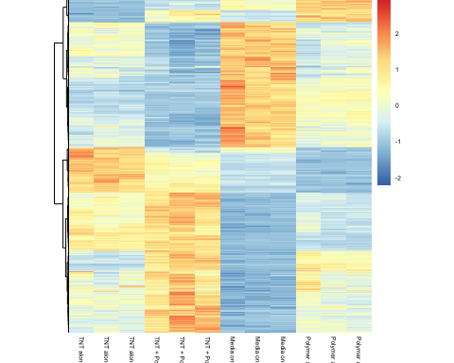

# Your existing lists  
Media_data <- rownames(sigs_8h1)  
Polymer_data <- rownames(sigs_8h1)  
  
print(length(Media_data))

## [1] 3472

TNT_data <- rownames(sigs_8h2)  
Polymer_and_TNT_data <- rownames(sigs_8h3)  
  
# Update Media with new rownames from sigs_8h2 and sigs_8h3  
Media_data <- union(Media_data, TNT_data)  
print(length(Media_data))

## [1] 7543

Media_data <- union(Media_data, Polymer_and_TNT_data)  
print(length(Media_data))

## [1] 9358

venn_df_Media <- data.frame(Media=Media_data)  
venn_df_Polymer <- data.frame(Polymer=Polymer_data)  
  
venn_df_Media$RowName <- venn_df_Media$Media  
venn_df_Polymer$RowName <-venn_df_Polymer$Polymer  
  
dat1 <- merge(venn_df_Media , venn_df_Polymer, by="RowName", all = T)  
  
  
venn_df_TNT <- data.frame(TNT=TNT_data)  
venn_df_Polymer_and_TNT <- data.frame(Polymer_and_TNT=Polymer_and_TNT_data)  
  
venn_df_TNT$RowName <- venn_df_TNT$TNT  
venn_df_Polymer_and_TNT$RowName <-venn_df_Polymer_and_TNT$Polymer_and_TNT  
  
dat2 <- merge(venn_df_TNT, venn_df_Polymer_and_TNT, by="RowName", all = T)  
dat3 <- merge(dat1, dat2, by="RowName", all = T)  
  
library(VennDiagram)

## Loading required package: futile.logger

#venn.diagram(dat3, filename = "venn-4-dimensions.png")  
  
#Error in `[[<-.data.frame`(`*tmp*`, i, value = c(NA, "ENSG00000000460", :  
#replacement has 3473 rows, data has 9358

write.csv(dat3, file = "dat3.csv", row.names = FALSE)

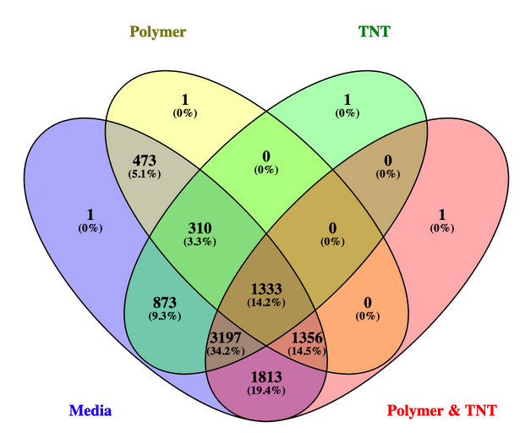

Fig

prepro_res <- function(res_xh) {  
 sigs_xh <-res_xh  
 sigs_xh <- na.omit(res_xh)  
 #sigs_xh <- sigs_xh[sigs_xh$padj < 0.05,]  
 df_sigs_xh <- as.data.frame(sigs_xh)  
 return(df_sigs_xh)  
}  
  
volc_8h1 <- prepro_res(res_8h1)  
volc_8h2 <- prepro_res(res_8h2)  
volc_8h3 <- prepro_res(res_8h3)

#Fucntion to plot volcano plot  
make_volc_plot <- function(volc_xhx,plot_name) {  
 sigs_xhx_results <- volc_xhx[order(volc_xhx$pvalue),]  
 results_order <- as.data.frame(dplyr::mutate(as.data.frame(sigs_xhx_results), sig=ifelse(sigs_xhx_results$pvalue<0.05, "FDR<0.05", "Not Sig")), row.names=rownames(sigs_xhx_results))  
   
 volcanoP <- ggplot(results_order, ggplot2::aes(log2FoldChange, -log10(pvalue))) +  
 geom_point(ggplot2::aes(col = sig)) +  
 scale_color_manual(values = c("red", "black")) +  
 ggtitle(plot_name)  
   
 volcanoP  
}

make_volc_plot(volc_8h1,"Media vs Polymer")

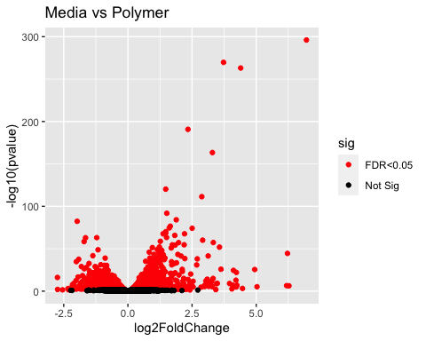

make_volc_plot(volc_8h2,"Media vs TNT alone")

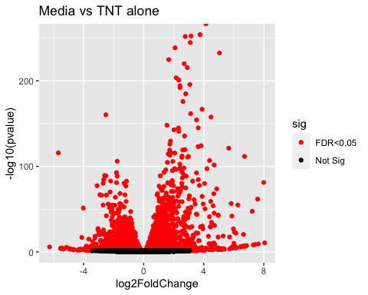

make_volc_plot(volc_8h3,"Media vs TNT+Polymer ")

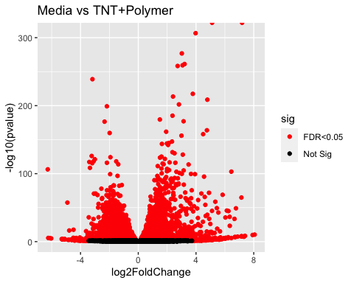

library(org.Hs.eg.db)

## Loading required package: AnnotationDbi

##   
## Attaching package: 'AnnotationDbi'

## The following object is masked from 'package:dplyr':  
##   
## select

##

library(fgsea)  
  
pathways.hallmark <- gmtPathways("h.all.v7.2.symbols.gmt")  
  
plot_pathways<-function(res_xhx,plot_title){  
   
 ens2symbol <- AnnotationDbi::select(org.Hs.eg.db,  
 key=rownames(res_xhx),   
 columns="SYMBOL",  
 keytype="ENSEMBL")  
 ens2symbol <- as_tibble(ens2symbol)  
   
 sigs_xhx_results <- res_xhx[order(res_xhx$pvalue),]  
 sigs_xhx_results$ENSEMBL <- rownames(sigs_xhx_results)  
 sigs_xhx_results <- inner_join(sigs_xhx_results, ens2symbol, by=c("ENSEMBL"="ENSEMBL"))  
 sigs_xhx_results <- sigs_xhx_results %>%  
 mutate(updown = ifelse(log2FoldChange > 0, "upregulated", "downregulated"))  
   
 res2 <- sigs_xhx_results %>%   
 dplyr::select(SYMBOL, stat,updown) %>%   
 na.omit() %>%   
 distinct() %>%   
 group_by(SYMBOL) %>%   
 summarize(stat=mean(stat), updown = first(updown))  
  
 ranks <- deframe(res2)  
   
 fgseaRes <- fgseaMultilevel(pathways=pathways.hallmark, stats=ranks)  
  
 # Tidy the results:  
 fgseaResTidy <- fgseaRes %>%  
 as_tibble() %>%  
 arrange(desc(NES)) # order by normalized enrichment score (NES)  
   
 # To see what genes are in each of these pathways:  
 gene.in.pathway <- pathways.hallmark %>%   
 enframe("pathway", "SYMBOL") %>%   
 unnest(cols = c(SYMBOL)) %>%   
 inner_join(res2, by="SYMBOL")  
   
 # Merge "updown" information with gene.in.pathway  
 gene.in.pathway <- gene.in.pathway %>%  
 inner_join(res2, by = "SYMBOL")  
   
 # Merge the enriched pathways information with fgseaResTidy  
 fgseaResTidy <- fgseaResTidy %>%  
 inner_join(gene.in.pathway, by = "pathway")  
   
 # Define the size breaks for the number of genes  
 size_breaks <- c(10, 50, 100, 200,300, Inf)  
   
 # Calculate the circle size based on the number of genes in each pathway  
 fgseaResTidy$gene_count_group <- cut(fgseaResTidy$size, breaks = size_breaks,   
 labels = c("10", "50", "100", "200","300"))  
   
 # Create a color palette for upregulation/downregulation  
 colors <- c("downregulated" = "blue", "upregulated" = "brown")  
   
 # Map colors to upregulation/downregulation  
 fgseaResTidy$circle_color <- colors[fgseaResTidy$updown.x]  
   
 # Create the plot  
 ggplot(fgseaResTidy, aes(-log10(padj), reorder(pathway, NES))) +  
 geom_point(aes(color = circle_color, size = gene_count_group)) +  
 scale_color_manual(values = c("blue", "brown")) +  
 scale_size_manual(values = c("10" = 1, "50" = 1.6, "100" = 2.4, "200" = 5, "300" = 6)) +  
 theme_minimal() +  
 theme(axis.text.x = element_text(angle = 90, vjust = 0.5, hjust = 1, size = 6),  
 axis.text.y = element_text(size = 6),  
 legend.text = element_text(size = 12))+  
 labs(x = "-log10(pval)", y = "Pathway",   
 title = plot_title) +  
 guides(size = guide_legend(title = "Gene Count Group"),   
 color = guide_legend(title = "Up/Down Regulation"))  
}

plot_pathways(volc_8h1,"Polymer only, 8hr")

## 'select()' returned 1:many mapping between keys and columns

## Warning: `x` must be a one- or two-column data frame in `deframe()`.

## Warning in preparePathwaysAndStats(pathways, stats, minSize, maxSize, gseaParam, : There are ties in the preranked stats (0.7% of the list).  
## The order of those tied genes will be arbitrary, which may produce unexpected results.

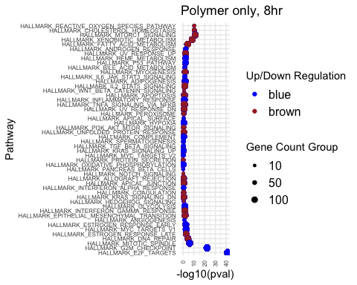

plot_pathways(volc_8h2,"TNT alone, 8hr")

## 'select()' returned 1:many mapping between keys and columns

## Warning: `x` must be a one- or two-column data frame in `deframe()`.

## Warning in preparePathwaysAndStats(pathways, stats, minSize, maxSize, gseaParam, : There are ties in the preranked stats (0.74% of the list).  
## The order of those tied genes will be arbitrary, which may produce unexpected results.

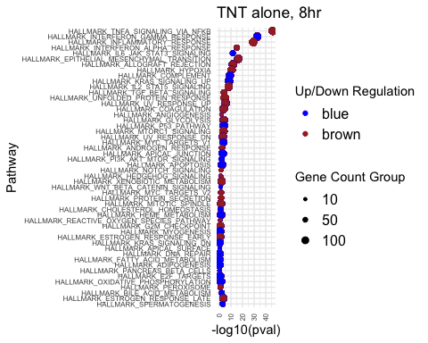

plot_pathways(volc_8h3,"TNT+ploymer, 8hr")

## 'select()' returned 1:many mapping between keys and columns

## Warning: `x` must be a one- or two-column data frame in `deframe()`.

## Warning in preparePathwaysAndStats(pathways, stats, minSize, maxSize, gseaParam, : There are ties in the preranked stats (0.8% of the list).  
## The order of those tied genes will be arbitrary, which may produce unexpected results.

